1. **INTRODUCTION**
   1. *overview*
      * *Description of the project*

Project Description:

EduConnect Learning Center, an educational institution, uses Zoho Books to manage their donations, track expenses, and handle grant finances. They can generate donor receipts, track expenses related to educational programs, and generate financial reports. Zoho Books helps them maintain financial transparency and accountability.

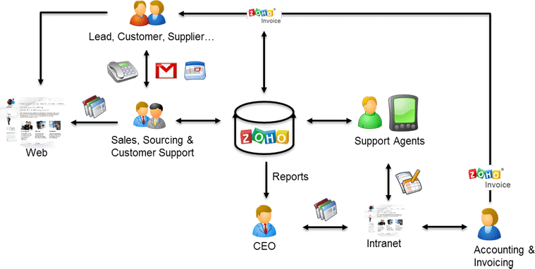

1. **Problem definition & design Thinking**
   1. *Empathy map*

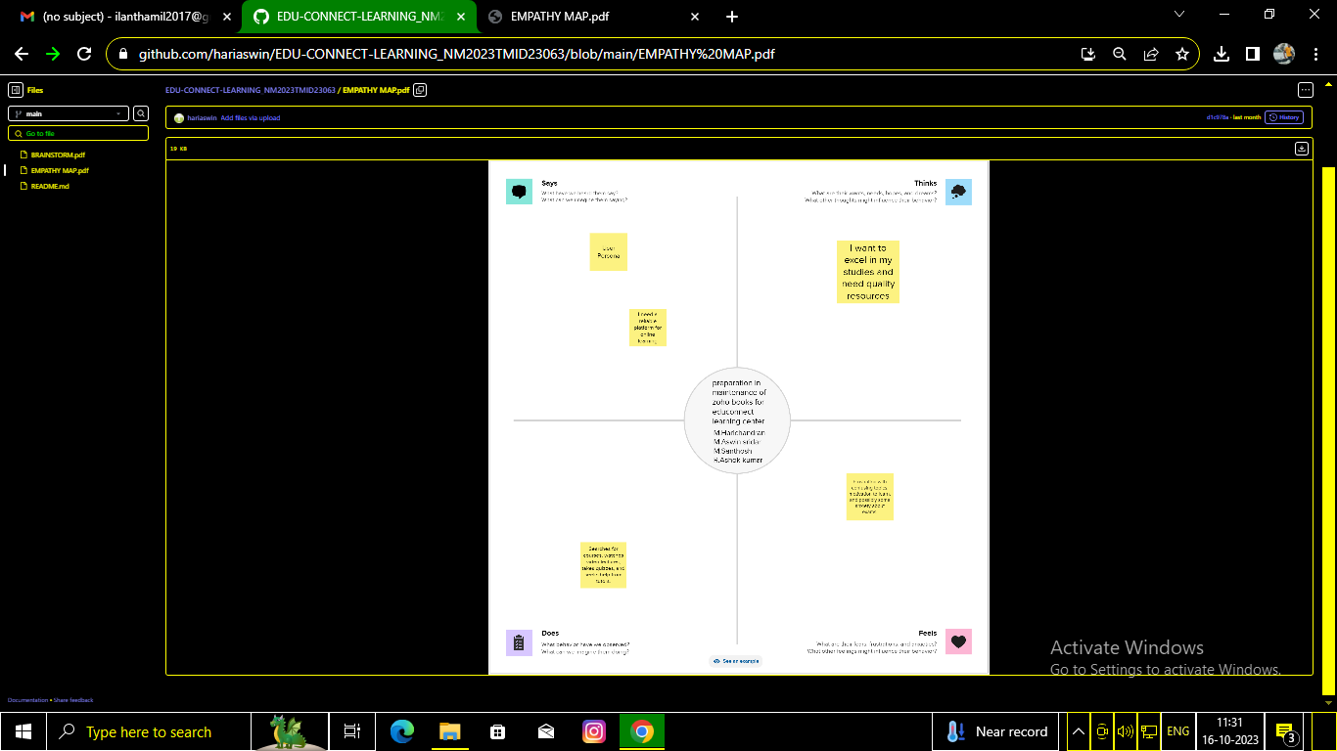

* 1. *Ideation & Brainstorming map*

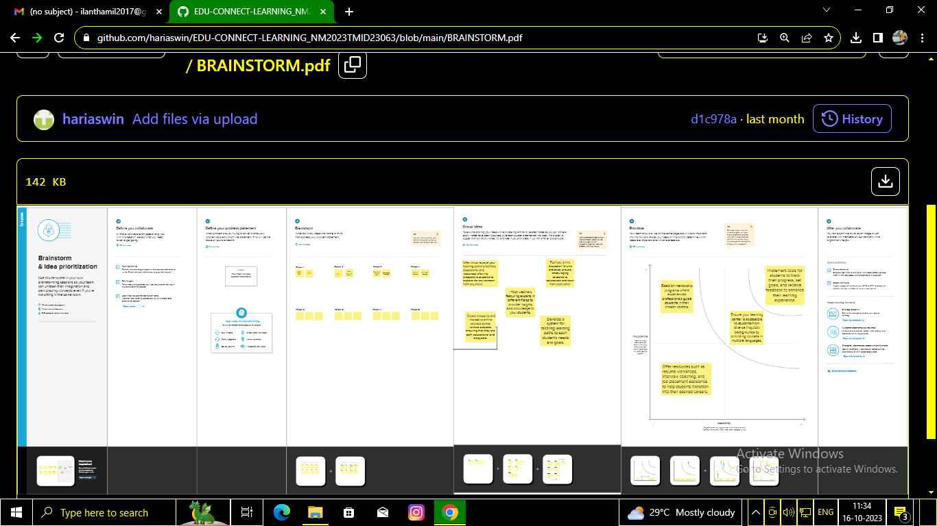

1. **Result Profit&loss**

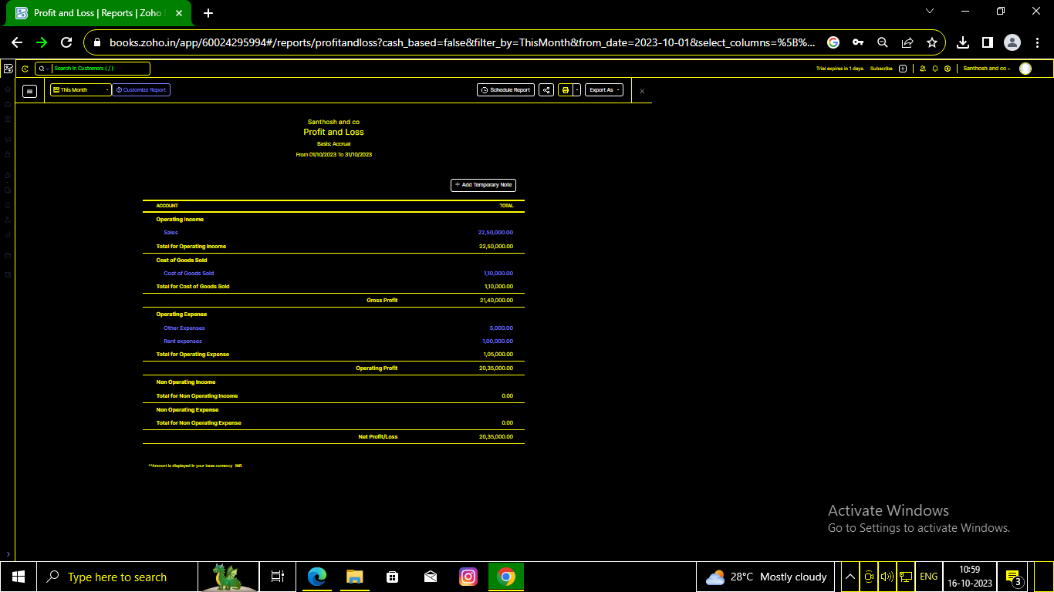

Balance sheet:

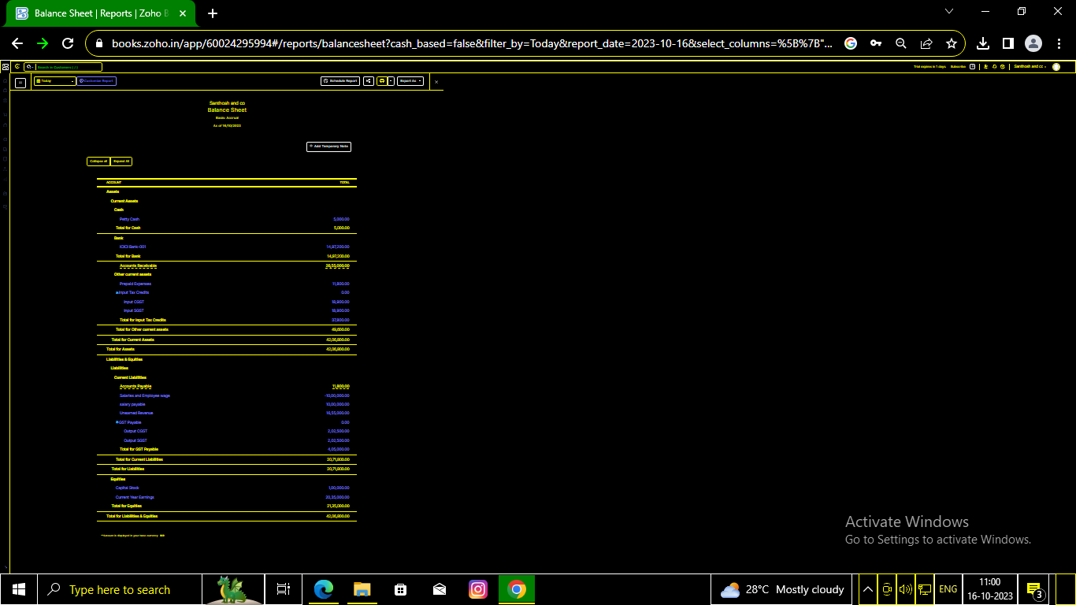

Purchase order:

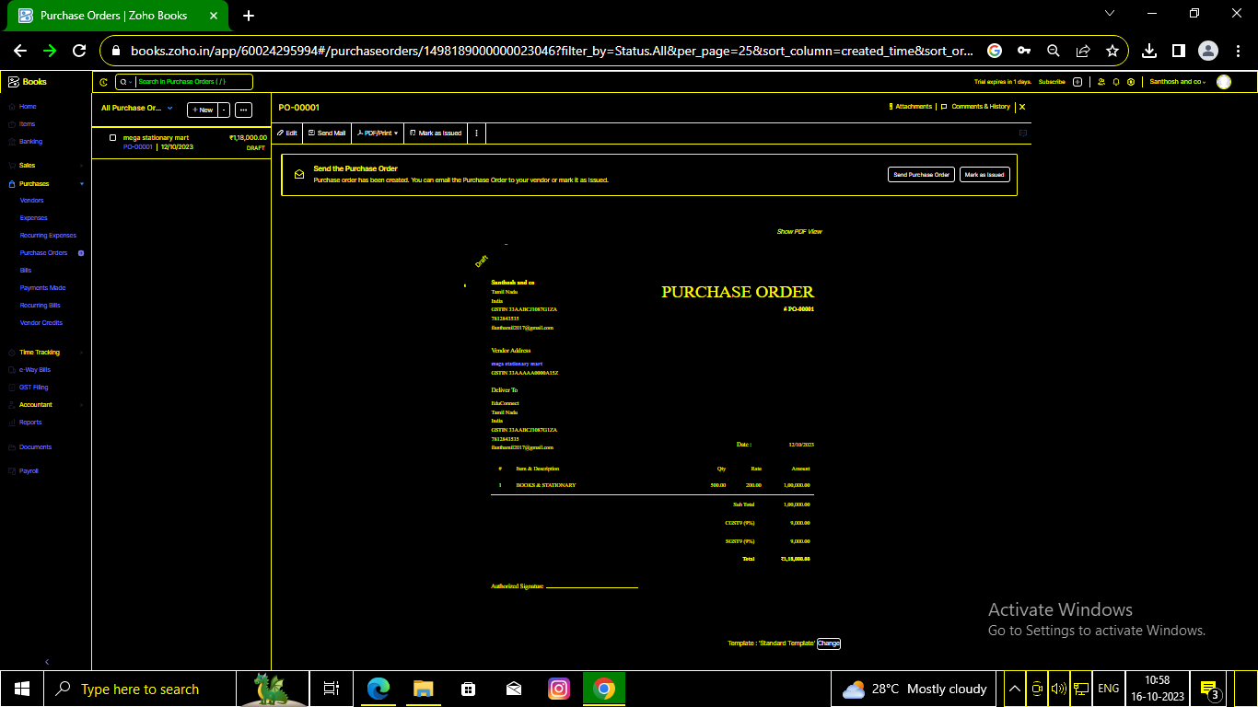

Sales order:

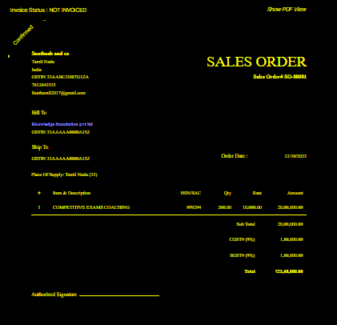

Invoice:

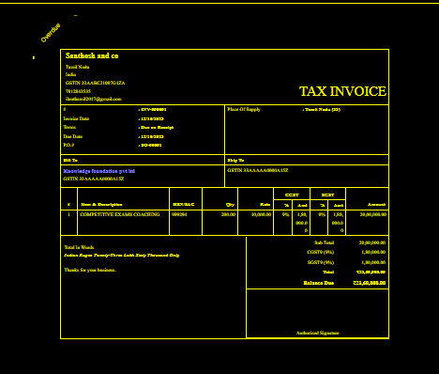

Bills:

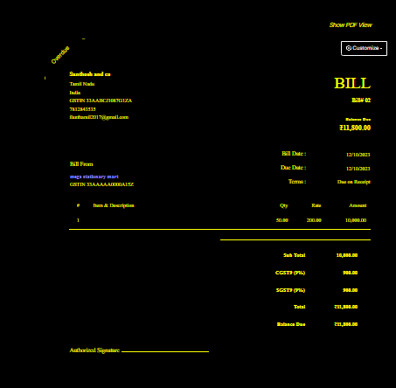

ADVANTAGES OF EDUCONNECT LEARNING :

Online learning offers teachers an efficient way to deliver lessons to students. Online learning has a number of tools such as videos, PDFs, podcasts, and teachers can use all these tools as part of their lesson plans. By extending the lesson plan beyond traditional textbooks to include online resources, teachers are able to become more efficient educators.

DISADVANTAGES OF EDUCONNECT LEARNING:

For many students, one of the biggest challenges of online learning is the struggle with focusing on the screen for long periods of time. With online learning, there is also a greater chance for students to be easily distracted by social media or other sites. Therefore, it is imperative for the teachers to keep their online classes crisp, engaging, and interactive to help students stay focused on the lesson.

1. ***APPLICATIONS***

EDUCONNECT LEARNING CENTER

1. **CONCLSUION:**

Inadequate healthcare is prevalent globally in all countries, and no country has a perfect healthcare system.

1. **FUTURE SCOPE:**

Online education is much more cost-effective. Students just have to pay the course fee and be done with it. There are no other charges like hostel fees, library fees, maintenance fees, etc. Since you study at your own time, it helps to save time as well.

1. **APPENDIX:**

<https://github.com/hariaswin/Educonnect>

|  |
| --- |
| <!DOCTYPE html> |
|  | <html lang="en" data-color-mode="auto" data-light-theme="light" data-dark-theme="dark" data-a11y-animated-images="system" data-a11y-link-underlines="false"> |
|  |  |
|  | <style> |
|  | /* for each iteration, uncomment the CSS variable */ |
|  |  |
|  | /* light themes */ |
|  | [data-color-mode="light"][data-light-theme*="light"], |
|  | [data-color-mode="auto"][data-light-theme*="light"] { |
|  | /* iteration 1 */ |
|  | --border-color-iteration-1: #C8CCD0; |
|  | /* iteration 2 */ |
|  | --border-color-iteration-2: #BABFC5; |
|  | /* iteration 3 */ |
|  | --border-color-iteration-3: #A6ADB4; |
|  | /* iteration final */ |
|  | --border-color-iteration-4: #868F99; |
|  |  |
|  | /* the first value is the final step, which falls back to previous iterations */ |
|  | --control-borderColor-rest: var(--border-color-iteration-4, var(--border-color-iteration-3, var(--border-color-iteration-2, var(--border-color-iteration-1)))) !important; |
|  | } |
|  |  |
|  | /* dark themes */ |
|  | [data-color-mode="dark"][data-dark-theme*="dark"], |
|  | [data-color-mode="auto"][data-light-theme*="dark"] { |
|  | /* iteration 1 */ |
|  | --border-color-iteration-1: #363940; |
|  | /* iteration 2 */ |
|  | --border-color-iteration-2: #3F434B; |
|  | /* iteration 3 */ |
|  | --border-color-iteration-3: #4B5159; |
|  | /* iteration final */ |
|  | --border-color-iteration-4: #666E79; |
|  |  |
|  | /* the first value is the final step, which falls back to previous iterations */ |
|  | --control-borderColor-rest: var(--border-color-iteration-4, var(--border-color-iteration-3, var(--border-color-iteration-2, var(--border-color-iteration-1)))) !important; |
|  | } |
|  |  |
|  | [data-color-mode="dark"][data-dark-theme="dark_dimmed"], |
|  | [data-color-mode="dark"][data-dark-theme="light_high_contrast"], |
|  | [data-color-mode="dark"][data-dark-theme="dark_high_contrast"], |
|  | [data-color-mode="light"][data-light-theme="dark_dimmed"], |
|  | [data-color-mode="light"][data-light-theme="light_high_contrast"], |
|  | [data-color-mode="light"][data-light-theme="dark_high_contrast"] { |
|  | /* skip these themes, use the fallback */ |
|  | --control-borderColor-rest: initial !important; |
|  | } |
|  |  |
|  | @media (prefers-color-scheme: dark) { |
|  | /* dark colors in dark mode */ |
|  | [data-color-mode="auto"][data-dark-theme*="dark"] { |
|  | /* iteration 1 */ |
|  | --border-color-iteration-1: #363940; |
|  | /* iteration 2 */ |
|  | --border-color-iteration-2: #3F434B; |
|  | /* iteration 3 */ |
|  | --border-color-iteration-3: #4B5159; |
|  | /* iteration final */ |
|  | --border-color-iteration-4: #666E79; |
|  |  |
|  | /* the first value is the final step, which falls back to previous iterations */ |
|  | --control-borderColor-rest: var(--border-color-iteration-4, var(--border-color-iteration-3, var(--border-color-iteration-2, var(--border-color-iteration-1)))) !important; |
|  | } |
|  |  |
|  | /* light colors in dark mode */ |
|  | [data-color-mode="auto"][data-dark-theme*="light"] { |
|  | /* iteration 1 */ |
|  | --border-color-iteration-1: #C8CCD0; |
|  | /* iteration 2 */ |
|  | --border-color-iteration-2: #BABFC5; |
|  | /* iteration 3 */ |
|  | --border-color-iteration-3: #A6ADB4; |
|  | /* iteration final */ |
|  | --border-color-iteration-4: #868F99; |
|  |  |
|  | /* the first value is the final step, which falls back to previous iterations */ |
|  | --control-borderColor-rest: var(--border-color-iteration-4, var(--border-color-iteration-3, var(--border-color-iteration-2, var(--border-color-iteration-1)))) !important; |
|  | } |
|  |  |
|  | [data-color-mode="auto"][data-dark-theme="dark_dimmed"], |
|  | [data-color-mode="auto"][data-dark-theme="light_high_contrast"], |
|  | [data-color-mode="auto"][data-dark-theme="dark_high_contrast"] { |
|  | /* skip these themes, use the fallback */ |
|  | --control-borderColor-rest: initial !important; |
|  | } |
|  | } |
|  |  |
|  | @media (prefers-color-scheme: light) { |
|  | /* dark colors in light mode */ |
|  | [data-color-mode="auto"][data-light-theme*="dark"] { |
|  | /* iteration 1 */ |
|  | --border-color-iteration-1: #363940; |
|  | /* iteration 2 */ |
|  | --border-color-iteration-2: #3F434B; |
|  | /* iteration 3 */ |
|  | --border-color-iteration-3: #4B5159; |
|  | /* iteration final */ |
|  | --border-color-iteration-4: #666E79; |
|  |  |
|  | /* the first value is the final step, which falls back to previous iterations */ |
|  | --control-borderColor-rest: var(--border-color-iteration-4, var(--border-color-iteration-3, var(--border-color-iteration-2, var(--border-color-iteration-1)))) !important; |
|  | } |
|  |  |
|  | /* light colors in light mode */ |
|  | [data-color-mode="auto"][data-light-theme*="light"] { |
|  | /* iteration 1 */ |
|  | --border-color-iteration-1: #C8CCD0; |
|  | /* iteration 2 */ |
|  | --border-color-iteration-2: #BABFC5; |
|  | /* iteration 3 */ |
|  | --border-color-iteration-3: #A6ADB4; |
|  | /* iteration final */ |
|  | --border-color-iteration-4: #868F99; |
|  |  |
|  | /* the first value is the final step, which falls back to previous iterations */ |
|  | --control-borderColor-rest: var(--border-color-iteration-4, var(--border-color-iteration-3, var(--border-color-iteration-2, var(--border-color-iteration-1)))) !important; |
|  | } |
|  |  |
|  | [data-color-mode="auto"][data-light-theme="dark_dimmed"], |
|  | [data-color-mode="auto"][data-light-theme="light_high_contrast"], |
|  | [data-color-mode="auto"][data-light-theme="dark_high_contrast"] { |
|  | /* skip these themes, use the fallback */ |
|  | --control-borderColor-rest: initial !important; |
|  | } |
|  | } |

|  |  |
| --- | --- |
|  |  |
|  |  |
|  |  |
|  |  |
|  |  |
|  |  |
|  |  |

rel=”stylesheet” href=”./NM2023TMID22539_profit_and_loss.pdf at main · asmku643mku643c1c31260_NM2023TMID22539 · GitHub_files/light-b92e9647318f.css”><link crossorigin=”anonymous” media=”all” rel=”stylesheet” href=”./NM2023TMID22539_profit_and_loss.pdf at main · asmku643mku643c1c31260_NM2023TMID22539 · GitHub_files/dark-5d486a4ede8e.css”><link data-color-theme=”dark_dimmed” crossorigin=”anonymous” media=”all” rel=”stylesheet” data-href=https://github.githubassets.com/assets/dark_dimmed-27c8d635e4e5.css><link data-color-theme=”dark_high_contrast” crossorigin=”anonymous” media=”all”

rel=”stylesheet”

data-href=https://github.githubassets.com/assets/dark_high_contrast-8438e75afd36.css><lin k data-color-theme=”dark_colorblind” crossorigin=”anonymous” media=”all” rel=”stylesheet” data-href=https://github.githubassets.com/assets/dark_colorblind-bf5665b96628.css><link data-color-theme=”light_colorblind” crossorigin=”anonymous” media=”all” rel=”stylesheet” data-href=https://github.githubassets.com/assets/light_colorblind-c414b5ba1dce.css><link data-color-theme=”light_high_contrast” crossorigin=”anonymous” media=”all” rel=”stylesheet”

data-href=https://github.githubassets.com/assets/light_high_contrast-e5868b7374db.css><lin k data-color-theme=”light_tritanopia” crossorigin=”anonymous” media=”all” rel=”stylesheet” data-href=https://github.githubassets.com/assets/light_tritanopia-299ac9c64ec0.css><link data-color-theme=”dark_tritanopia” crossorigin=”anonymous” media=”all” rel=”stylesheet” data-href=h[ttps://github.githubassets.com/assets/dark_tritanopia-3a26e78ad0ff.css>](https://github.githubassets.com/assets/light_high_contrast-e5868b7374db.css)

<link cros[sorigin=”anonymous” media=”all” rel=”stylesheet”](https://github.githubassets.com/assets/dark_tritanopia-3a26e78ad0ff.css) href=”./NM2023TMID22539_profit_and_loss.pdf at main · asmku643mku643c1c31260_NM2023TMID22539 · GitHub_files/primer-primitives-6143c8f97ed1.css”>

<link crossorigin=”anonymous” media=”all” rel=”stylesheet” href=”./NM2023TMID22539_profit_and_loss.pdf at main · asmku643mku643c1c31260_NM2023TMID22539 · GitHub_files/primer-d6dcdf72e61d.css”>

<link crossorigin=”anonymous” media=”all” rel=”stylesheet” href=”./NM2023TMID22539_profit_and_loss.pdf at main · asmku643mku643c1c31260_NM2023TMID22539 · GitHub_files/global-ab1c3e3e5644.css”>

<link crossorigin=”anonymous” media=”all” rel=”stylesheet” href=”./NM2023TMID22539_profit_and_loss.pdf at main · asmku643mku643c1c31260_NM2023TMID22539 · GitHub_files/github-757ef6ea9a38.css”>

<link crossorigin=”anonymous” media=”all” rel=”stylesheet” href=”./NM2023TMID22539_profit_and_loss.pdf at main · asmku643mku643c1c31260_NM2023TMID22539 · GitHub_files/code-71ecd5638fbf.css”>

<script type=”application/json”

id=”client-env”>{“locale”:”en”,”featureFlags”:[“failbot_handle_non_errors”,”geojson_azure_m aps”,”image_metric_tracking”,”turbo_experiment_risky”,”sample_network_conn_type”]}</scri pt>

<script crossorigin=”anonymous” defer=”defer” type=”application/javascript” src=”./NM2023TMID22539_profit_and_loss.pdf at main · asmku643mku643c1c31260_NM2023TMID22539 ·

GitHub_files/wp-runtime-86f14561f3b0.js.download”></script>

<script crossorigin=”anonymous” defer=”defer” type=”application/javascript” src=”./NM2023TMID22539_profit_and_loss.pdf at main · asmku643mku643c1c31260_NM2023TMID22539 ·

GitHub_files/vendors-node_modules_dompurify_dist_purify_js-64d590970fa6.js.download”>

</script>

<script crossorigin=”anonymous” defer=”defer” type=”application/javascript” src=”./NM2023TMID22539_profit_and_loss.pdf at main · asmku643mku643c1c31260_NM2023TMID22539 ·

GitHub_files/vendors-node_modules_stacktrace-parser_dist_stack-trace-parser_esm_js-node_ modules_github_bro-a4c183-18bf85b8e9f4.js.download”></script>

<script crossorigin=”anonymous” defer=”defer” type=”application/javascript” src=”./NM2023TMID22539_profit_and_loss.pdf at main · asmku643mku643c1c31260_NM2023TMID22539 ·

GitHub_files/ui_packages_soft-nav_soft-nav_ts-56133143b228.js.download”></script>

<script crossorigin=”anonymous” defer=”defer” type=”application/javascript” src=”./NM2023TMID22539_profit_and_loss.pdf at main · asmku643mku643c1c31260_NM2023TMID22539 ·

GitHub_files/environment-fc6543d75794.js.download”></script>

<script crossorigin=”anonymous” defer=”defer” type=”application/javascript” src=”./NM2023TMID22539_profit_and_loss.pdf at main · asmku643mku643c1c31260_NM2023TMID22539 ·

GitHub_files/vendors-node_modules_github_selector-observer_dist_index_esm_js-2646a2c53 3e3.js.download”></script>

<script crossorigin=”anonymous” defer=”defer” type=”application/javascript” src=”./NM2023TMID22539_profit_and_loss.pdf at main · asmku643mku643c1c31260_NM2023TMID22539 ·

GitHub_files/vendors-node_modules_primer_behaviors_dist_esm_focus-zone_js-d55308df50 23.js.download”></script>

<script crossorigin=”anonymous” defer=”defer” type=”application/javascript” src=”./NM2023TMID22539_profit_and_loss.pdf at main · asmku643mku643c1c31260_NM2023TMID22539 ·

GitHub_files/vendors-node_modules_github_relative-time-element_dist_index_js-99e288659 d4f.js.download”></script>

<script crossorigin=”anonymous” defer=”defer” type=”application/javascript” src=”./NM2023TMID22539_profit_and_loss.pdf at main · asmku643mku643c1c31260_NM2023TMID22539 ·

GitHub_files/vendors-node_modules_fzy_js_index_js-node_modules_github_combobox-nav_ dist_index_js-node_modu-344bff-91b70bb50d68.js.download”></script>

<script crossorigin=”anonymous” defer=”defer” type=”application/javascript” src=”./NM2023TMID22539_profit_and_loss.pdf at main · asmku643mku643c1c31260_NM2023TMID22539 ·

GitHub_files/vendors-node_modules_delegated-events_dist_index_js-node_modules_github_ auto-complete-element-81d69b-f766607dc0c8.js.download”></script>

<script crossorigin=”anonymous” defer=”defer” type=”application/javascript” src=”./NM2023TMID22539_profit_and_loss.pdf at main · asmku643mku643c1c31260_NM2023TMID22539 ·

GitHub_files/vendors-node_modules_github_filter-input-element_dist_index_js-node_module s_github_remote-inp-2e8678-d593bf262480.js.download”></script>

<script crossorigin=”anonymous” defer=”defer” type=”application/javascript” src=”./NM2023TMID22539_profit_and_loss.pdf at main · asmku643mku643c1c31260_NM2023TMID22539 ·

GitHub_files/vendors-node_modules_github_file-attachment-element_dist_index_js-node_m odules_primer_view-co-70ad06-9f8bb7e4a8fa.js.download”></script>

<script crossorigin=”anonymous” defer=”defer” type=”application/javascript” src=”./NM2023TMID22539_profit_and_loss.pdf at main · asmku643mku643c1c31260_NM2023TMID22539 ·

GitHub_files/github-elements-30961cfd137b.js.download”></script>

<script crossorigin=”anonymous” defer=”defer” type=”application/javascript” src=”./NM2023TMID22539_profit_and_loss.pdf at main · asmku643mku643c1c31260_NM2023TMID22539 ·

GitHub_files/element-registry-e5f51987a7c5.js.download”></script>

<script crossorigin=”anonymous” defer=”defer” type=”application/javascript” src=”./NM2023TMID22539_profit_and_loss.pdf at main · asmku643mku643c1c31260_NM2023TMID22539 ·

GitHub_files/vendors-node_modules_lit-html_lit-html_js-4ccebb6ebf7d.js.download”></script

>

<script crossorigin=”anonymous” defer=”defer” type=”application/javascript” src=”./NM2023TMID22539_profit_and_loss.pdf at main · asmku643mku643c1c31260_NM2023TMID22539 ·

GitHub_files/vendors-node_modules_github_mini-throttle_dist_index_js-node_modules_gith ub_alive-client_dist-bf5aa2-504c8d53fb8e.js.download”></script>

<script crossorigin=”anonymous” defer=”defer” type=”application/javascript” src=”./NM2023TMID22539_profit_and_loss.pdf at main · asmku643mku643c1c31260_NM2023TMID22539 ·

GitHub_files/vendors-node_modules_morphdom_dist_morphdom-esm_js-b1fdd7158cf0.js.do wnload”></script>

<script crossorigin=”anonymous” defer=”defer” type=”application/javascript” src=”./NM2023TMID22539_profit_and_loss.pdf at main · asmku643mku643c1c31260_NM2023TMID22539 ·

GitHub_files/vendors-node_modules_github_turbo_dist_turbo_es2017-esm_js-9a3541181451

.js.download”></script>

<script crossorigin=”anonymous” defer=”defer” type=”application/javascript” src=”./NM2023TMID22539_profit_and_loss.pdf at main · asmku643mku643c1c31260_NM2023TMID22539 ·

GitHub_files/vendors-node_modules_github_remote-form_dist_index_js-node_modules_scrol l-anchoring_dist_scro-52dc4b-e1e33bfc0b7e.js.download”></script>

<script crossorigin=”anonymous” defer=”defer” type=”application/javascript” src=”./NM2023TMID22539_profit_and_loss.pdf at main · asmku643mku643c1c31260_NM2023TMID22539 ·

GitHub_files/vendors-node_modules_color-convert_index_js-35b3ae68c408.js.download”></s cript>

<script crossorigin=”anonymous” defer=”defer” type=”application/javascript” src=”./NM2023TMID22539_profit_and_loss.pdf at main · asmku643mku643c1c31260_NM2023TMID22539 ·

GitHub_files/vendors-node_modules_primer_behaviors_dist_esm_dimensions_js-node_modu les_github_jtml_lib_index_js-a18147cea3a6.js.download”></script>

<script crossorigin=”anonymous” defer=”defer” type=”application/javascript” src=”./NM2023TMID22539_profit_and_loss.pdf at main ·

asmku643mku643c1c31260_NM2023TMID22539 ·

GitHub_files/vendors-node_modules_github_paste-markdown_dist_index_esm_js-node_mod ules_github_quote-select-581a1f-4a3074d34892.js.download”></script>

<script crossorigin=”anonymous” defer=”defer” type=”application/javascript” src=”./NM2023TMID22539_profit_and_loss.pdf at main · asmku643mku643c1c31260_NM2023TMID22539 · GitHub_files/app_assets_modules_github_details-dialog_ts-app_assets_modules_github_fetc h_ts-add1ab03ecb3.js.download”></script>

<script crossorigin=”anonymous” defer=”defer” type=”application/javascript” src=”./NM2023TMID22539_profit_and_loss.pdf at main · asmku643mku643c1c31260_NM2023TMID22539 · GitHub_files/app_assets_modules_github_updatable-content_ts-ui_packages_hydro-analytics

_hydro-analytics_ts-0a5a30c9b976.js.download”></script>

<script crossorigin=”anonymous” defer=”defer” type=”application/javascript” src=”./NM2023TMID22539_profit_and_loss.pdf at main · asmku643mku643c1c31260_NM2023TMID22539 · GitHub_files/app_assets_modules_github_onfocus_ts-app_assets_modules_github_sticky-scr oll-into-view_ts-c56a5dfc8975.js.download”></script>

<script crossorigin=”anonymous” defer=”defer” type=”application/javascript” src=”./NM2023TMID22539_profit_and_loss.pdf at main · asmku643mku643c1c31260_NM2023TMID22539 · GitHub_files/app_assets_modules_github_behaviors_task-list_ts-app_assets_modules_github

_sso_ts-ui_packages-7d50ad-9491f2be61ee.js.download”></script>

<script crossorigin=”anonymous” defer=”defer” type=”application/javascript” src=”./NM2023TMID22539_profit_and_loss.pdf at main · asmku643mku643c1c31260_NM2023TMID22539 · GitHub_files/app_assets_modules_github_behaviors_ajax-error_ts-app_assets_modules_gith ub_behaviors_include-2e2258-d77f85c54572.js.download”></script>

<script crossorigin=”anonymous” defer=”defer” type=”application/javascript” src=”./NM2023TMID22539_profit_and_loss.pdf at main · asmku643mku643c1c31260_NM2023TMID22539 · GitHub_files/app_assets_modules_github_behaviors_commenting_edit_ts-app_assets_modul es_github_behaviors_ht-83c235-f22ac6b94445.js.download”></script>

<script crossorigin=”anonymous” defer=”defer” type=”application/javascript” src=”./NM2023TMID22539_profit_and_loss.pdf at main · asmku643mku643c1c31260_NM2023TMID22539 ·

GitHub_files/behaviors-8e3546d05c82.js.download”></script>

<script crossorigin=”anonymous” defer=”defer” type=”application/javascript” src=”./NM2023TMID22539_profit_and_loss.pdf at main · asmku643mku643c1c31260_NM2023TMID22539 ·

GitHub_files/vendors-node_modules_delegated-events_dist_index_js-node_modules_github_ catalyst_lib_index_js-623425af41e1.js.download”></script>

<script crossorigin=”anonymous” defer=”defer” type=”application/javascript” src=”./NM2023TMID22539_profit_and_loss.pdf at main · asmku643mku643c1c31260_NM2023TMID22539 ·

GitHub_files/notifications-global-0104a8043aa4.js.download”></script>

<script crossorigin=”anonymous” defer=”defer” type=”application/javascript” src=”./NM2023TMID22539_profit_and_loss.pdf at main · asmku643mku643c1c31260_NM2023TMID22539 ·

GitHub_files/vendors-node_modules_optimizely_optimizely-sdk_dist_optimizely_browser_es

_min_js-node_modules-089adc-8794271c9a65.js.download”></script>

<script crossorigin=”anonymous” defer=”defer” type=”application/javascript” src=”./NM2023TMID22539_profit_and_loss.pdf at main · asmku643mku643c1c31260_NM2023TMID22539 ·

GitHub_files/optimizely-b8ae60018b11.js.download”></script>

<script crossorigin=”anonymous” defer=”defer” type=”application/javascript” src=”./NM2023TMID22539_profit_and_loss.pdf at main · asmku643mku643c1c31260_NM2023TMID22539 ·

GitHub_files/vendors-node_modules_virtualized-list_es_index_js-node_modules_github_tem plate-parts_lib_index_js-677582870bfd.js.download”></script>

<script crossorigin=”anonymous” defer=”defer” type=”application/javascript” src=”./NM2023TMID22539_profit_and_loss.pdf at main · asmku643mku643c1c31260_NM2023TMID22539 ·

GitHub_files/vendors-node_modules_github_remote-form_dist_index_js-node_modules_dele gated-events_dist_inde-c537341-13ba07af3b2c.js.download”></script>

<script crossorigin=”anonymous” defer=”defer” type=”application/javascript” src=”./NM2023TMID22539_profit_and_loss.pdf at main · asmku643mku643c1c31260_NM2023TMID22539 · GitHub_files/app_assets_modules_github_ref-selector_ts-cad36de2ca60.js.download”></scrip t>

<script crossorigin=”anonymous” defer=”defer” type=”application/javascript” src=”./NM2023TMID22539_profit_and_loss.pdf at main ·

asmku643mku643c1c31260_NM2023TMID22539 · GitHub_files/codespaces-d5d24842ceda.js.download”></script>

<script crossorigin=”anonymous” defer=”defer” type=”application/javascript” src=”./NM2023TMID22539_profit_and_loss.pdf at main · asmku643mku643c1c31260_NM2023TMID22539 ·

GitHub_files/vendors-node_modules_github_filter-input-element_dist_index_js-node_module s_github_mini-throt-08ab15-d50c69097a3e.js.download”></script>

<script crossorigin=”anonymous” defer=”defer” type=”application/javascript” src=”./NM2023TMID22539_profit_and_loss.pdf at main · asmku643mku643c1c31260_NM2023TMID22539 ·

GitHub_files/vendors-node_modules_github_file-attachment-element_dist_index_js-node_m odules_github_mini-th-55cf52-b2acd5425c7c.js.download”></script>

<script crossorigin=”anonymous” defer=”defer” type=”application/javascript” src=”./NM2023TMID22539_profit_and_loss.pdf at main · asmku643mku643c1c31260_NM2023TMID22539 ·

GitHub_files/repositories-b80504a04cf8.js.download”></script>

<script crossorigin=”anonymous” defer=”defer” type=”application/javascript” src=”./NM2023TMID22539_profit_and_loss.pdf at main · asmku643mku643c1c31260_NM2023TMID22539 ·

GitHub_files/vendors-node_modules_github_remote-form_dist_index_js-node_modules_dele gated-events_dist_inde-0e9dbe-6435366f0862.js.download”></script>

<script crossorigin=”anonymous” defer=”defer” type=”application/javascript” src=”./NM2023TMID22539_profit_and_loss.pdf at main · asmku643mku643c1c31260_NM2023TMID22539 ·

GitHub_files/topic-suggestions-2e55863e3751.js.download”></script>

<script crossorigin=”anonymous” defer=”defer” type=”application/javascript” src=”./NM2023TMID22539_profit_and_loss.pdf at main · asmku643mku643c1c31260_NM2023TMID22539 ·

GitHub_files/code-menu-6bd50a0647d6.js.download”></script>

<meta http-equiv=”x-pjax-version” content=”d98aab6b69dc43e4407b1369c7bbfcf76dfab2d839011937153201c9b943f42f” data-turbo-track=”reload”>

<meta http-equiv=”x-pjax-csp-version” content=”ee14a7165914197d62e19f664bfb961fcfdfc1ec31939a5c7b137fbab1751c87” data-turbo-track=”reload”>

<meta http-equiv=”x-pjax-css-version” content=”664233c3fea08fdf2ac6994c09da8d00c5e5f750fe523a7605f44e0aafe71afe” data-turbo-track=”reload”>

<meta http-equiv=”x-pjax-js-version” content=”dd74378fedb3de5476a9fb9b72cce29ed416c09618bddd59f59777f848393889” data-turbo-track=”reload”>

<style type=”text/css” id=”operaUserStyle”></style>

<script type=”application/javascript” src=”./NM2023TMID22539_profit_and_loss.pdf at main

· asmku643mku643c1c31260_NM2023TMID22539 · GitHub_files/react-lib-210c4b5934c3.js.download”></script><script

type=”application/javascript” src=”./NM2023TMID22539_profit_and_loss.pdf at main · asmku643mku643c1c31260_NM2023TMID22539 ·

GitHub_files/vendors-node_modules_primer_octicons-react_dist_index_esm_js-node_module s_primer_react_lib-es-3db9ab-5f4faa9f1811.js.download”></script><script type=”application/javascript” src=”./NM2023TMID22539_profit_and_loss.pdf at main · asmku643mku643c1c31260_NM2023TMID22539 ·

GitHub_files/vendors-node_modules_primer_react_lib-esm_Box_Box_js-96a44addc402.js.do wnload”></script><script type=”application/javascript” src=”./NM2023TMID22539_profit_and_loss.pdf at main · asmku643mku643c1c31260_NM2023TMID22539 ·

GitHub_files/vendors-node_modules_primer_react_lib-esm_Button_Button_js-node_modules

_primer_react_lib-esm_-f6da63-1976b80d3486.js.download”></script><script type=”application/javascript” src=”./NM2023TMID22539_profit_and_loss.pdf at main · asmku643mku643c1c31260_NM2023TMID22539 ·

GitHub_files/vendors-node_modules_primer_react_lib-esm_Truncate_Truncate_js-node_mod

ules_primer_react_lib—5d1957-92534314547a.js.download”></script><script type=”application/javascript” src=”./NM2023TMID22539_profit_and_loss.pdf at main · asmku643mku643c1c31260_NM2023TMID22539 ·

GitHub_files/vendors-node_modules_primer_react_lib-esm_Button_index_js-node_modules_ primer_react_lib-esm_O-279bf8-c9a61955d545.js.download”></script><script type=”application/javascript” src=”./NM2023TMID22539_profit_and_loss.pdf at main · asmku643mku643c1c31260_NM2023TMID22539 ·

GitHub_files/vendors-node_modules_primer_react_lib-esm_Text_Text_js-node_modules_pri mer_react_lib-esm_Text-85a14b-0f28951279b7.js.download”></script><script type=”application/javascript” src=”./NM2023TMID22539_profit_and_loss.pdf at main · asmku643mku643c1c31260_NM2023TMID22539 ·

GitHub_files/vendors-node_modules_primer_react_lib-esm_ActionList_index_js-535c8ee1ebe 8.js.download”></script><script type=”application/javascript” src=”./NM2023TMID22539_profit_and_loss.pdf at main · asmku643mku643c1c31260_NM2023TMID22539 ·

GitHub_files/vendors-node_modules_primer_react_lib-esm_ActionMenu_ActionMenu_js-2f0 8ef908241.js.download”></script><script type=”application/javascript” src=”./NM2023TMID22539_profit_and_loss.pdf at main · asmku643mku643c1c31260_NM2023TMID22539 · GitHub_files/vendors-